Head:

Head can do whatever employee and representative do.

Approve / Reject Requisition

After department head log in, approve requisition screen will show as default screen.

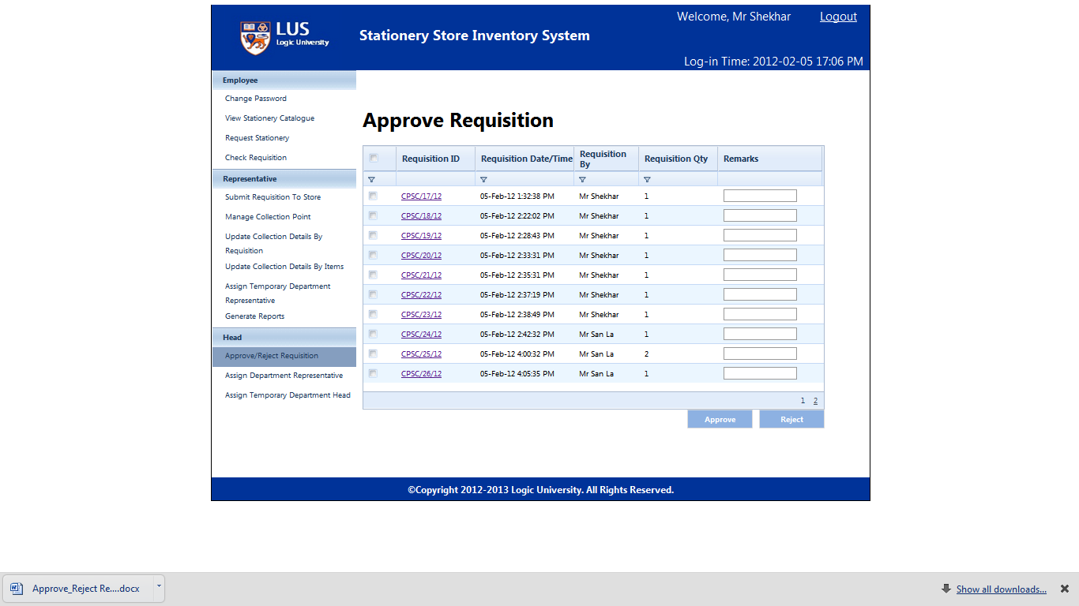

Click requisition id, head can view requisition detail.

(s)

Head can modify required qty.

(s)

Click “Approve” then system will automatically send approved requisition to representative.

(s)

Before click “Approve” or “Reject”, user needs to select desire requisitions from the requisition list.

Clicking the check box from top left column will select all the requisitions.

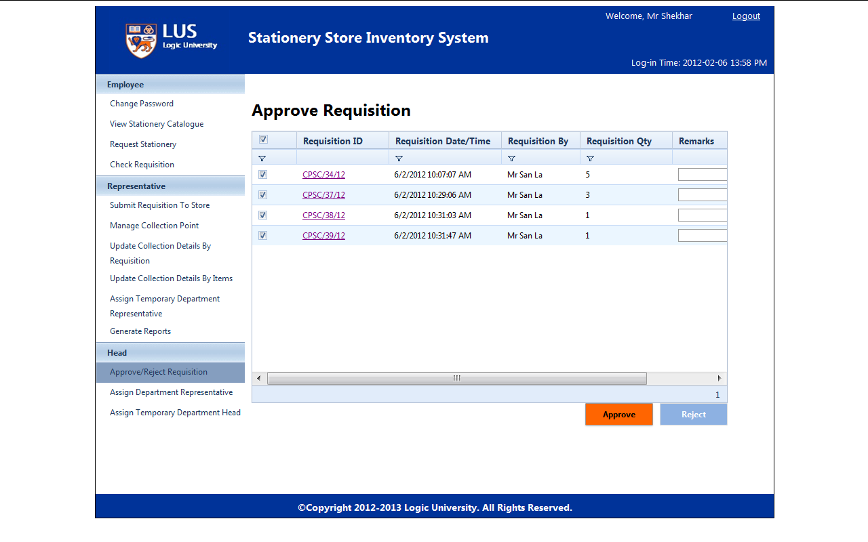

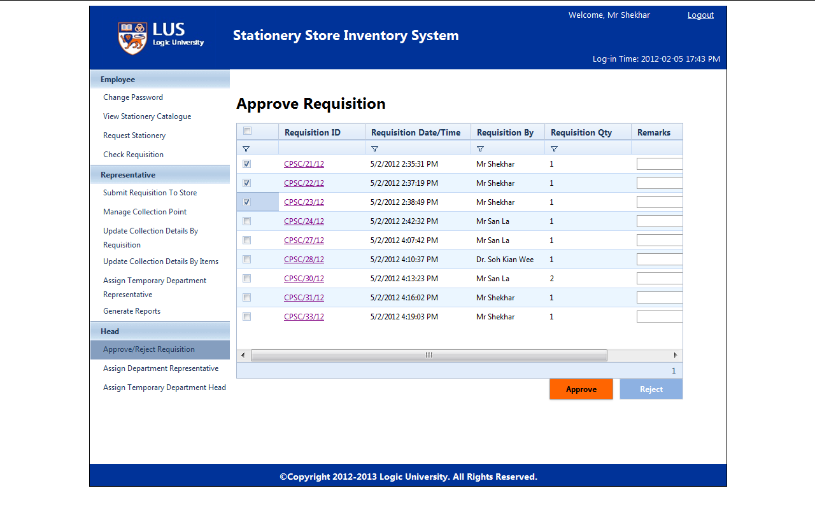

Click Reject button to reject all the requisitions which have selected before.

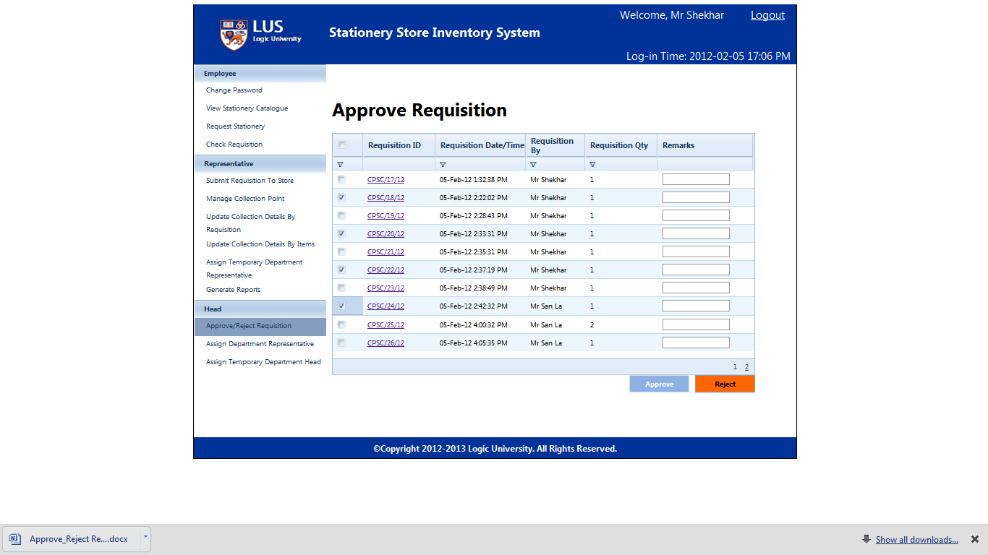

Department head can also give remarks before approve or reject.

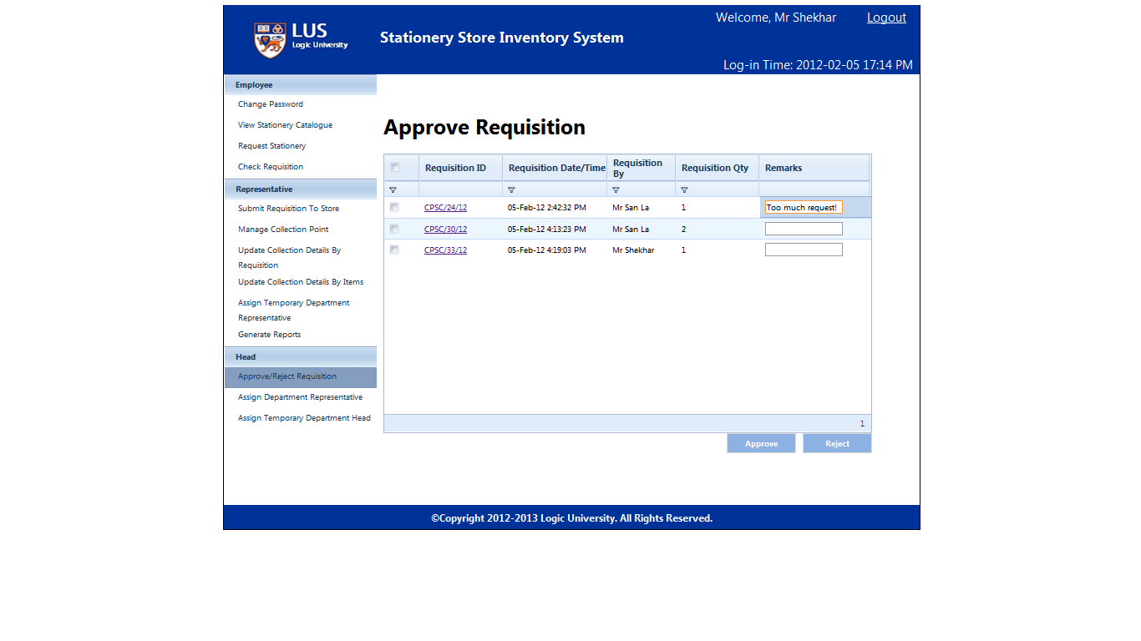

Department head click “Requisition ID” then can view requisition detail , modify required qty as well.

(s)